NAME: CHRISTINA JOSE MANAKKAL

ROLL NO: 48 CLASS: TEITB PID: 191064

**St. Francis Institute of Technology, Mumbai-400 103**

**Department Of Information Technology**

**A.Y. 2021-2022**

**Class: TE-ITA/B, Semester: V**

**Subject: DevOps Lab**

**Experiment – 3: To Perform various GIT operations on local and Remote repositories using GIT Cheat-Sheet**

**1. Aim:** To understand version control using Git and create a GitHub account

**2. Objectives:** Aim of this experiment is that, the students will be able

• To be aware of different Version Control tools like GIT and GitHub

• To obtain complete knowledge of the “version control system” to effectively track changes

augmented with Git and GitHub

**3. Outcomes:** After study of this experiment, the students will be able to

• Create and fork repositories in GitHub

• Apply branching, merging and rebasing concepts.

• Implement different Git workflow strategies in real-time scenarios

• Understand Git operations in IDE

**4. Prerequisite**: Knowledge of software engineering concept of version control

**5. Requirements:** Git, Personal Computer, Windows operating system, browser, Internet

Connection, Microsoft Word.

**6. Pre-Experiment Exercise:**

**Brief Theory:** Refer shared material

**7. Laboratory Exercise**

**A. Procedure:**

**a. Answer the following:**

• Give differences between Git and GitHub

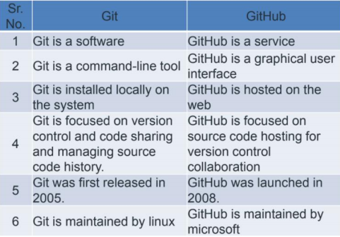

• What is Git Cheat sheet?

Git is the open source distributed version control system that facilitates

GitHub activities on your laptop or desktop. This cheat sheet summarizes

commonly used Git command line instructions for quick reference.

● Attach sample Git Cheat sheet

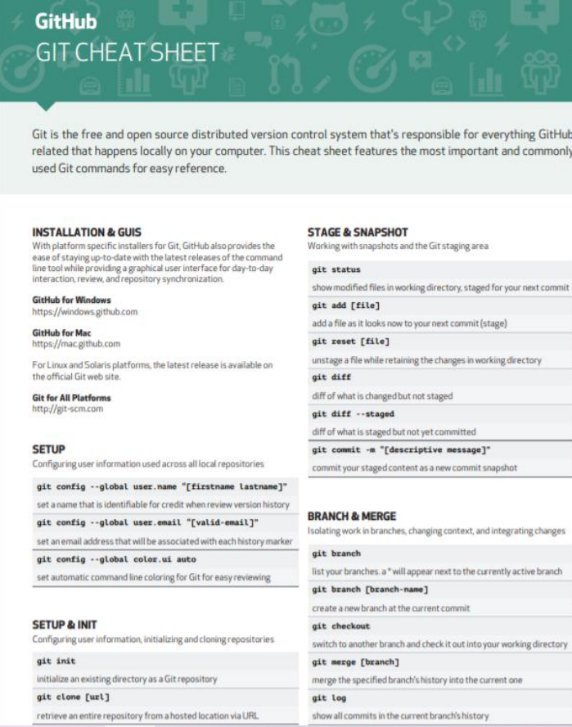

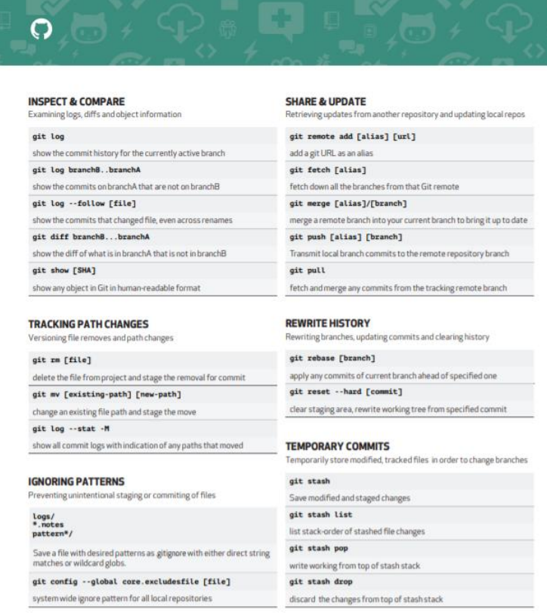

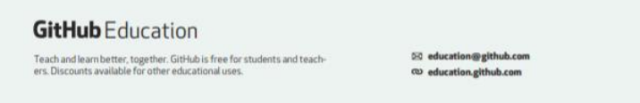

• Attach sample Git Cheat sheet

**b. Execute following on Git and GitHub (**Refer the shared material) and

attach screenshots:

• Create a repository in GitHub

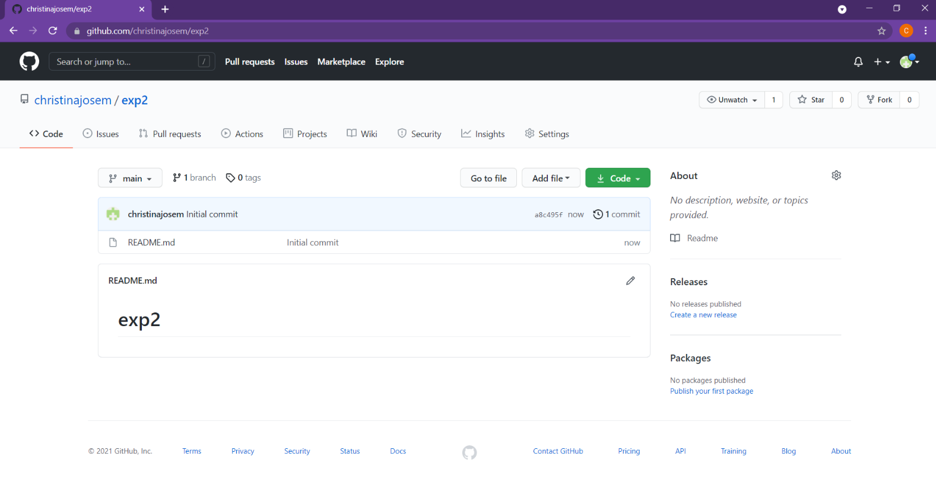

• Create a branch on repository

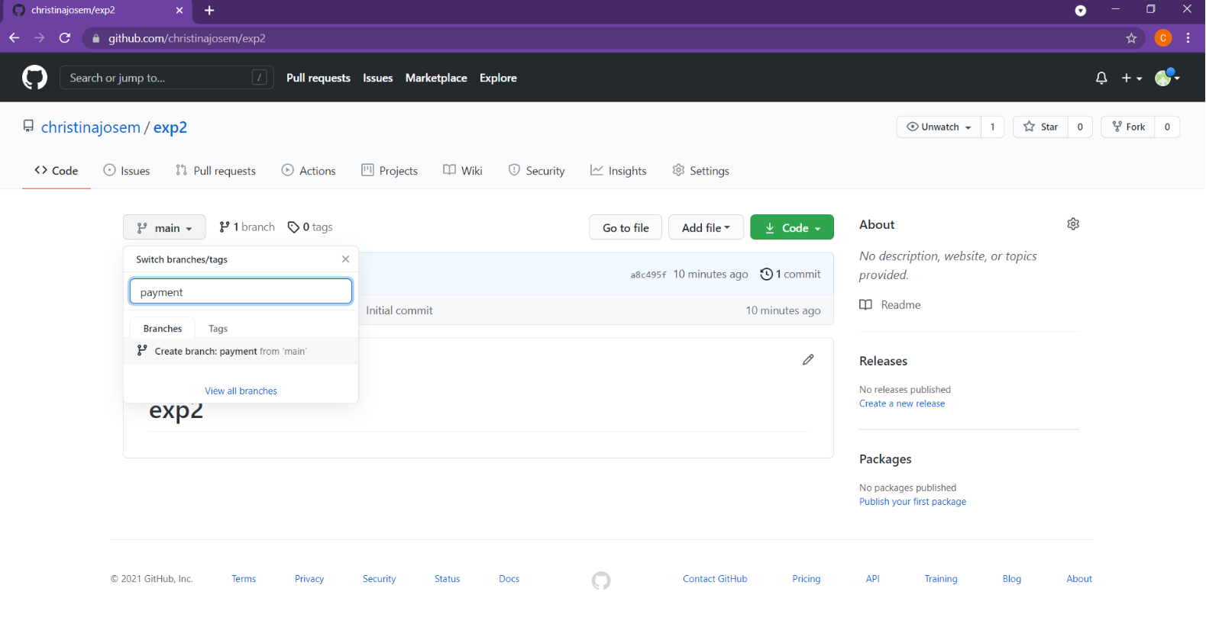

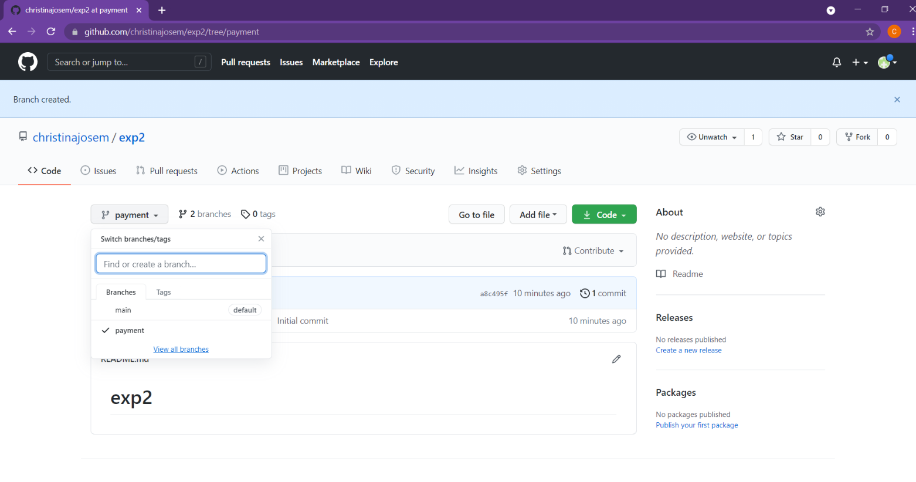

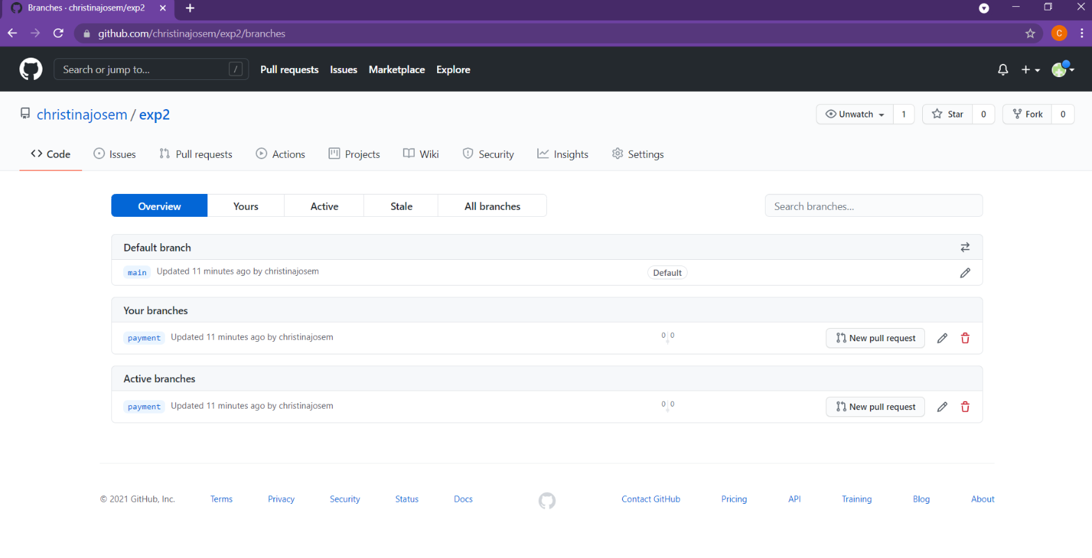

• Fork, push and Pull request

Push request:

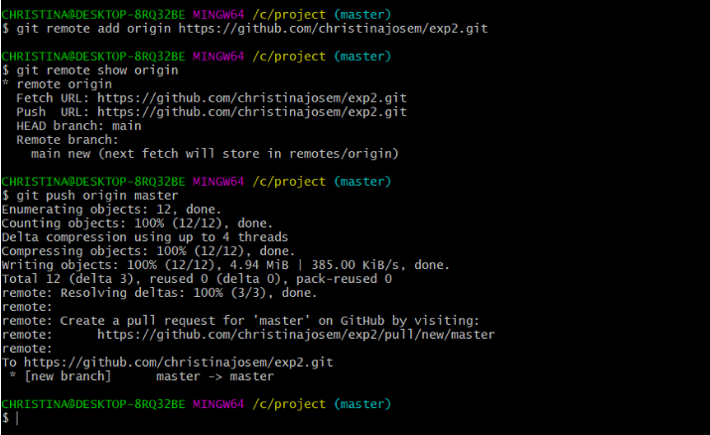

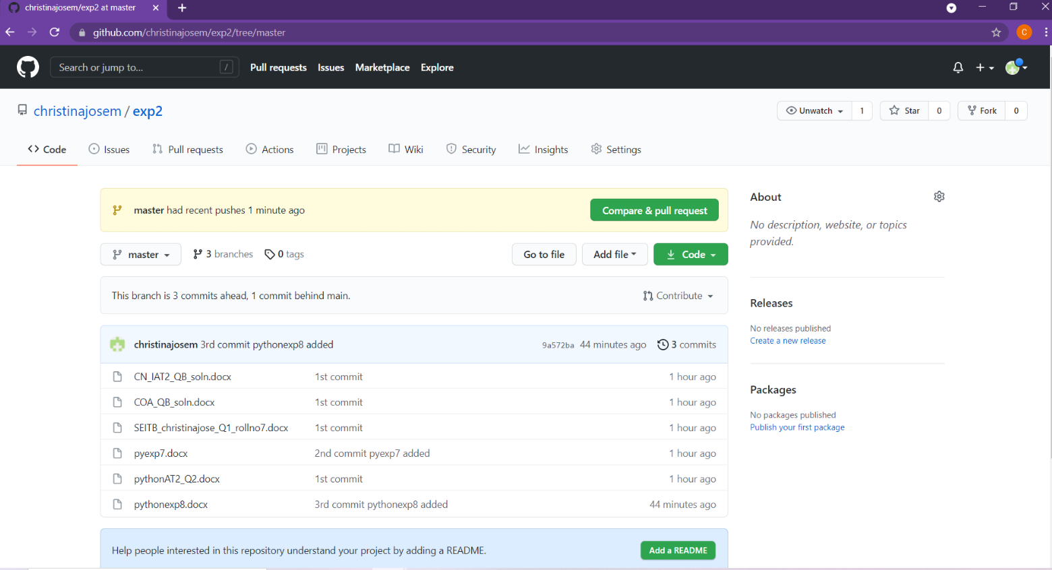

Pull request:

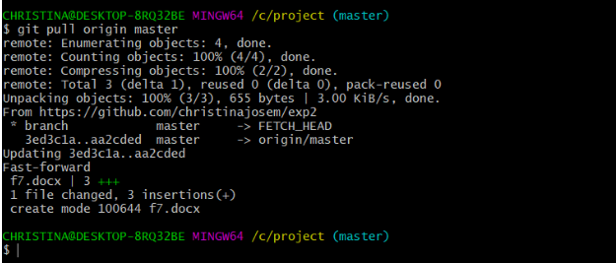

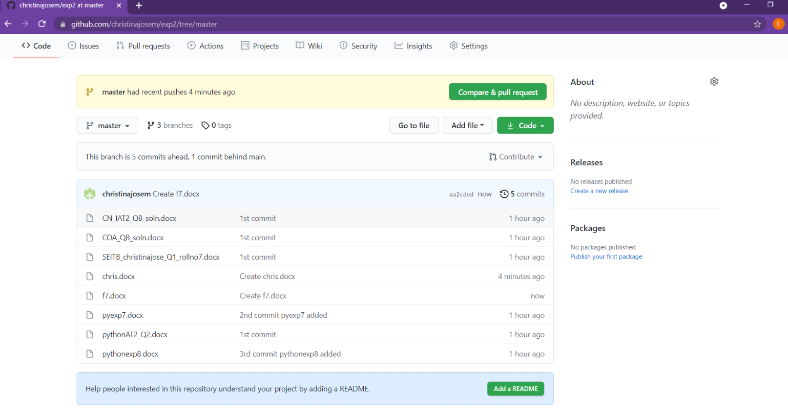

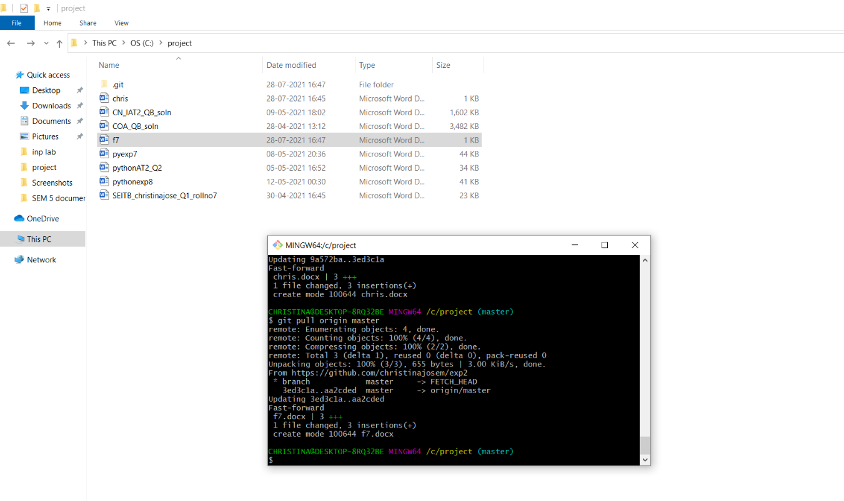

Fork :

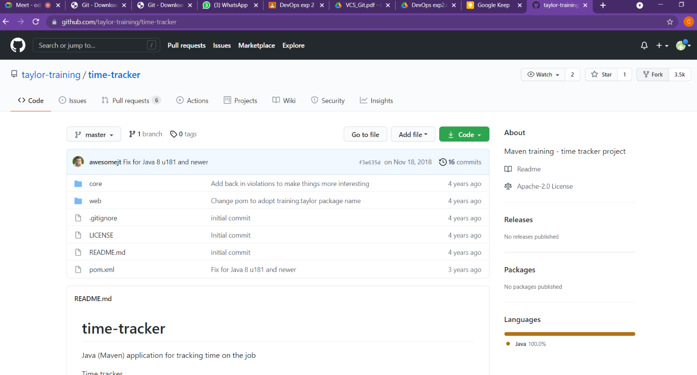

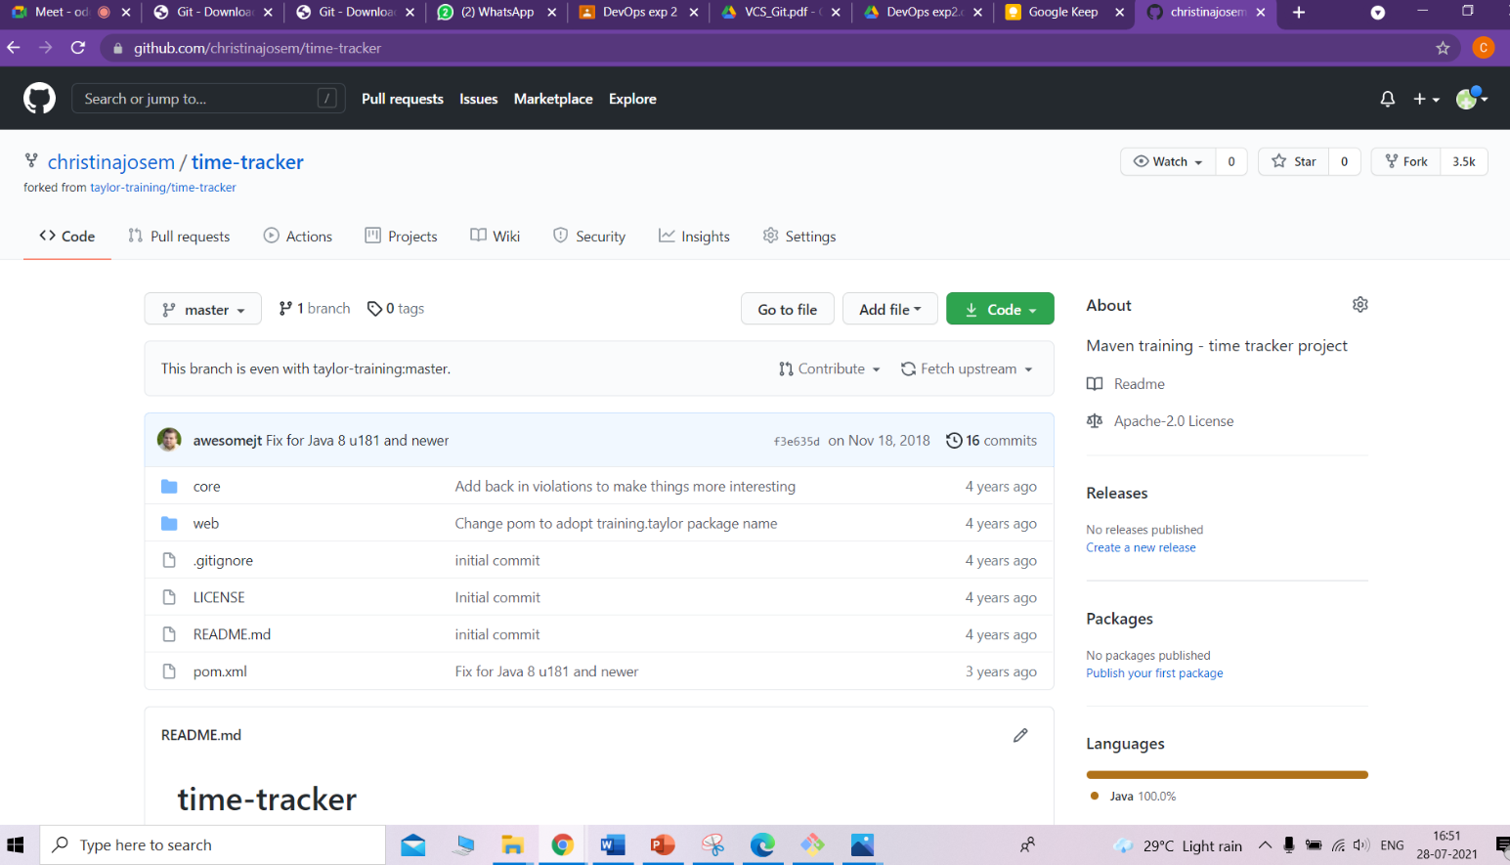

• Fetch and merge on Git

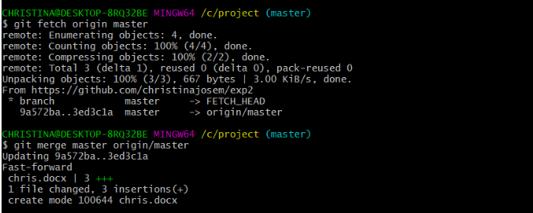

**8. Post-Experiments Exercise**

**A. Extended Theory:**

Nil

**B. Questions:**

• What are the different Git workflow strategies in real-time scenarios?

• What are the different Git IDEs available?

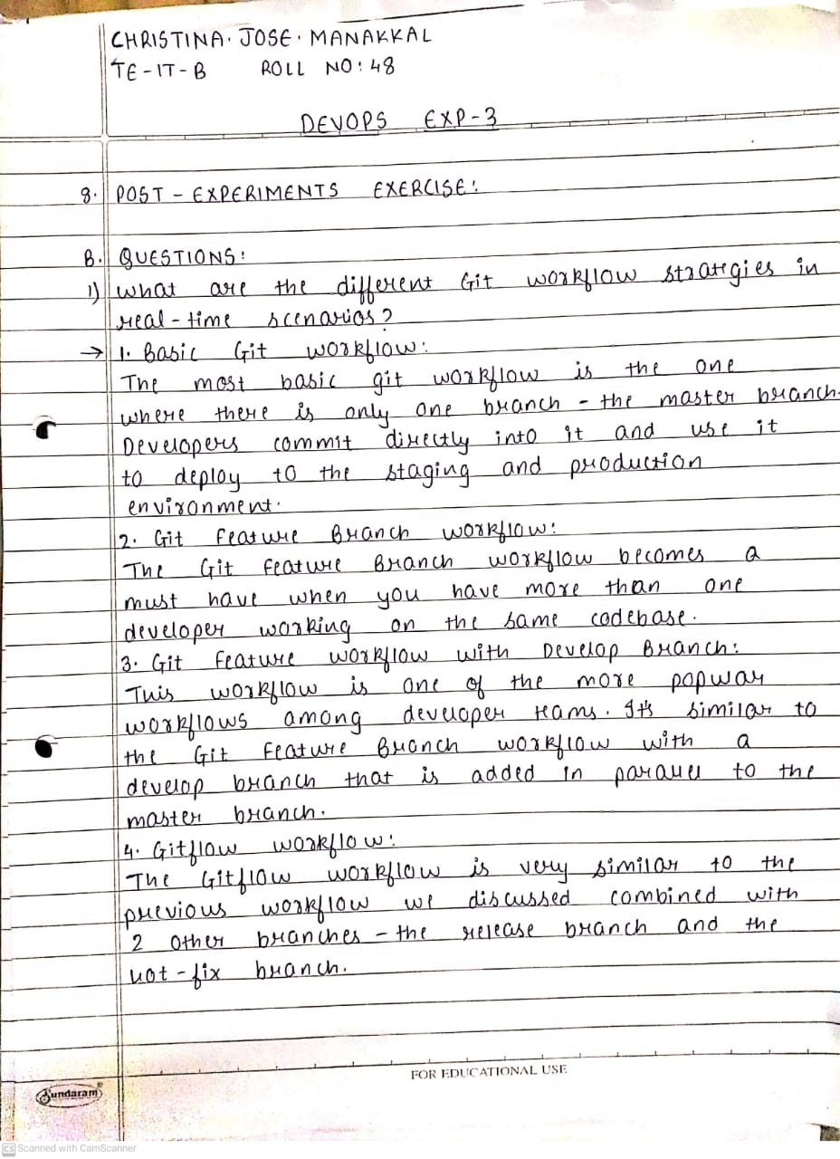

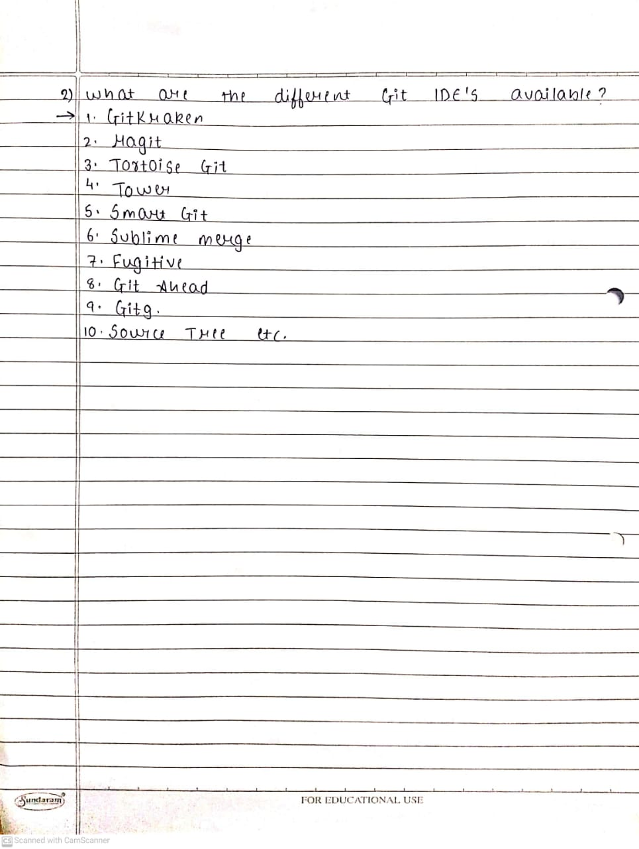

**C. Conclusion:**

• Write what was performed in the experiment.

• Write the significance of the topic studied in the experiment.

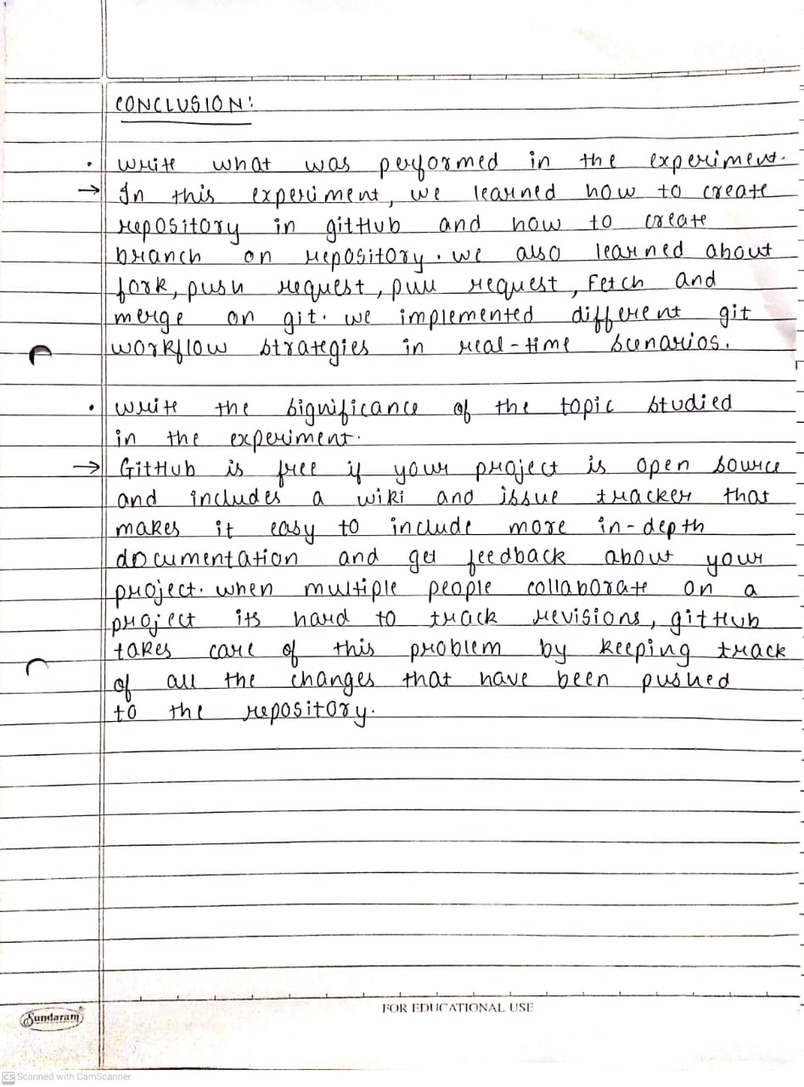

**D. References:**

<https://github.com/>

<https://guides.github.com/activities/hello-world/>

<https://git-scm.com/docs/gittutorial>